EXPLAINABLE ENSEMBLE MACHINE LEARNING FRAMEWORK

FOR EARLY HEART DISEASE PREDICTION

Katta Anoop (2420030503) • V. Sree (2420030490) • Sameera M (2420030582) • Souraja M (2420030537)
Group – 8
Under the guidance of Dr. K. Swanthana

ABSTRACT
Heart disease is a widespread health concern worldwide, and early identification of patients who have a higher risks of developing heart disease can contribute to clinical evaluation and treatment. There are machine learning models that can detect nonlinear associations between clinical features; however, an uninterpretable prediction without a comprehensible reason might be challenging in healthcare applications. This paper provides an Explainable Ensemble Machine Learning Framework for Early Heart Disease Prediction. The suggested system preprocesses a public heart disease dataset by cleaning, encoding categorical features, scaling numerical features and balancing classes. Feature selection is used to focus the learning process on input clinical features. Four classifiers complement each other—Logistic Regression, Random Forest, Support Vector Machine (SVM) and XGBoost—are combined via weighted soft voting. Also, the Decision Tree classifier serves as a baseline but not as part of the final ensemble. SHAP explains the prediction based on the contributions of each feature, and LIME provides the local explanation of the prediction at the patient level. The framework provides both risk prediction and explanation of it through a decision support dashboard. The project presentation provides improvements compared to the best baseline model of
0.80 percentage points in accuracy, 0.42 points in precision, 0.24 points in recall, 0.86 points in F1-score and 0.002 points in ROC-AUC. Absolute metric values, dataset splits description, hyperparameters and statistical significance values were not provided in the project materials and thus were not fabricated in this paper. The framework combines the predictive modelling and post-hoc explanation of the predictions to allow a transparent, reproducible investigation of heart disease risk prediction. Keywords: heart disease prediction, machine learning, ensemble learning, weighted soft voting, feature selection, explainable AI, SHAP, LIME, clinical decision support.

INTRODUCTION

Background

CVDs stand out as the most prevalent causes of death worldwide. The report provided by WHO states that 19.8 million people have lost their lives due to CVDs in 2022, accounting for 32% of all deaths. Therefore, the significance of the early identification and treatment of CVDs is highlighted [1]. Heart disease prediction can be considered another application field of data-driven clinical decision support systems. Traditional statistical models such as logistic regression retain their importance due to higher levels of interpretability, whereas machine-learning classifiers allow for modelling more complicated associations [4,26].

To solve the presented problem, the project will make use of multiple machine-learning classifiers rather than rely only on one classifier.

The integration of several learners with different inductive biases within ensemble learning can enhance the robustness of the model [6–8]. In the developed system, Logistic Regression, Random Forest, SVM, and XGBoost will contribute to the result through weighted probability voting. In addition, SHAP and LIME will be included in the project to provide both the result and its interpretation.

Problem Statement

Most of the heart disease prediction systems concentrate mainly on classification efficiency. Nevertheless, it might be hard for the system to be implemented as a decision support tool if it becomes impossible to understand which attributes of the patient influenced the prediction process. Besides, most of the research applies different sets of data, data pre-processing procedures, classifiers, and evaluation methods, making the results incomparable [21–25]. Thus, the issue being tackled in this study consists in developing a framework for predicting heart disease risks that integrates various classifiers and explains patients' predictions.

Research Gap

The literature presents an abundant amount of research on machine learning prediction, ensemble techniques, and explainable AI but these topics are usually explored independently and with distinct validation approaches. Review papers on healthcare XAI point out the problems related to the quality of explanations, evaluation criteria, replicability, and requirements of the target users [21-23]. Recent papers on heart disease prediction prove the efficiency of both ensembles and XAI, but also indicate varying results according to the dataset and evaluation approach [24-30]. The project thus pays attention to the single pipeline in which feature selection, heterogeneous ensemble prediction, and two types of explanation will be used within the final decision support process.

Methodological transparency is another gap addressed by this paper. The material presented within the project specifies the structure of the algorithm and performance gains of models but does not include all the exact experimental details yet.

Research Objectives
    - Develop a machine-learning pipeline for early heart-disease risk prediction.
    - Preprocess healthcare data through cleaning, encoding, scaling, and class balancing.
    - Apply feature selection to focus the models on important
clinical attributes.
    - Compare individual baseline classifiers with a heterogeneous ensemble.
    - Develop a weighted soft-voting ensemble using Logistic Regression, Random Forest, SVM, and XGBoost.
    - Generate global and patient-specific explanations using
SHAP and LIME.
    - Evaluate the system using accuracy, precision, recall, F1-score, ROC-AUC, and confusion-matrix analysis.
    - Present the prediction and explanation through a clear decision-support dashboard.

Research Questions

• RQ1: Is it possible to enhance the predictive capabilities by using a combination of complementary classifiers?

• RQ2: Is it possible to use feature selection to obtain a more concentrated input representation for the ensemble?

• RQ3: Is it possible to use weighted soft voting to combine probabilities produced by diverse learners?

• RQ4: Can SHAP and LIME help to obtain interpretable global and local explanations of the prediction?

• RQ5: How does the proposed framework perform in comparison to its individual baseline models?

Contributions

• An end-to-end process from preprocessing to explanation for early prediction of heart disease.

• A soft-voting ensemble algorithm using Logistic Regression, Random Forest, SVM, and XGBoost.

• Performing feature selection prior to ensemble learning.

• Utilization of SHAP and LIME for providing complementary explanations.

• A decision support process that not only gives a prediction but also significant factors behind the prediction.

• Transparency in reporting by separating the

numbers generated by the project currently from those to be experimentally verified.

Organisation of the Paper
Section 2 gives an overview of machine learning, ensemble, and explanation techniques. Section 3 explains the methodology to be used, data set, pre-processing, feature selection, ensemble design, baseline, and explanation techniques. Section 4 details the experimental setup and reporting. Section 5 explains the results that have been found in the course of the project till date and the numerical reporting needed still. Section 6 explains the results and their implications. Section 7 explains the limitations. Section 8 concludes the paper and discusses future work.

RELATED WORK

Existing Approaches
Early coronary-disease prediction research used statistical probability models and clinical variables to estimate disease likelihood. Detrano et al. developed and evaluated a probability algorithm for coronary artery disease using clinical and non-invasive test results across multiple patient groups [2]. The Cleveland heart-disease dataset later became a widely used benchmark for machine-learning experiments; the UCI repository describes the dataset as a classification dataset and records 303 instances and 13 commonly used features in the Cleveland database [3].
Recent studies have applied machine-learning methods to heart-disease prediction using logistic regression, random forests, SVMs, boosting, and other classifiers. An exploratory study using 1,670 anonymised medical records from a tertiary hospital in South India evaluated several machine-learning algorithms for cardiovascular prediction [26]. Studies using larger population datasets have also compared Logistic Regression, SVM, Random Forest, and XGBoost [28]. These studies show that model performance depends strongly on dataset characteristics, preprocessing, validation, and feature availability.

Machine Learning Approaches

Logistic Regression is essential as the coefficients of the model give relatively straightforward relationships between the input variables and the probability of a binary outcome [4]. SVM creates a decision boundary in the mapped space of features and is a very effective classifier for nonlinear classification when the right kind of kernel is applied [5]. Random Forest uses the technique of bagging and randomized feature selection and hence is considered as a powerful ensemble model [6]. XGBoost is an efficient scalable gradient-boosted system built on tree boosting and is popularly used for structured data classification [7].

In comparative health care research, there is no clear classifier which is consistently better than others. For instance, in a study using NHANES data, there was no significant difference in the performance of SVM, Logistic Regression, Random Forest, and XGBoost in predicting chronic heart disease, while in a cardiovascular risk study, advantages of ML algorithms were seen when compared to logistic regression [28,29].

Deep Learning Approaches

Deep learning techniques have become increasingly applied to healthcare for the modeling of complex signals and high-dimensional data. However, in this particular project, the approach focuses on the structured tabular data of heart disease attributes, and does not present the deep neural network as the model of choice. This has been done with purpose as the suggested system prefers a heterogeneous ensemble of already existing tabular classifiers together with the interpretable post-hoc explanations. From the healthcare AI literature, model selection must consider data modality and task among other things [21–23].

Explainability / Existing Techniques

LIME learns an interpretable function that approximates the local region of that data point [18]. SHAP offers feature attribution values for a model using concepts from Shapley values [19] and provides an overarching framework to interpret model predictions. Tree SHAP techniques are specifically tailored for tree-based model interpretations and can combine local explanations to understand the global behaviour of the model [20].

In the context of healthcare XAI, the importance of an explanation does not necessarily lie in whether it is mathematically feasible. Explanation efficiency depends on factors like fidelity, interpretability, plausibility, user satisfaction, task performance, and trust [21,23]. Recent studies have also shown that XAI can impact clinician trust differently in accordance with the explanation quality [22]. Hence, SHAP and LIME in this project should be considered explanation techniques, not alternatives to clinical validation.

Critical Comparison
Approach | Strength | Limitation | Relation to proposed work
Logistic Regression | Simple and relatively interpretable baseline | Limited ability to model complex nonlinear relationships | Included in final ensemble
Decision Tree | Easy to understand and visualise | Can be unstable and overfit | Baseline only; not in final ensemble
Random Forest | Robust tree ensemble and nonlinear modelling | Less directly interpretable as a whole | Included in final ensemble
SVM | Strong classification boundary; useful for nonlinear separation | Sensitive to scaling and hyperparameter choices | Included in final ensemble
XGBoost | Powerful gradient-boosted tree model | More complex and requires tuning | Included in final ensemble
LIME | Local, model-agnostic explanation | Local approximation can vary with sampling | Patient-level explanation
SHAP | Feature-attribution framework with local/global views | Can be computationally demanding depending on model | Feature contribution explanation
  - Research Gap

The findings provided in the literature review provide support to three observations. The first observation is that individual classifiers may behave differently on different datasets [26,28,29]. The second observation is that ensemble learning approaches can take advantage of complementary decision-making mechanisms [8,27,30]. Lastly, explainability is becoming more and more significant in the field of healthcare; however, it should be assessed carefully [21-23]. The framework we propose tackles these observations.

PROPOSED METHODOLOGY

Overall Framework

Heart-Disease Data

Data Preprocessing

Feature Selection

Four Base Models

Weighted Probability Voting

Final Risk Prediction

SHAP + LIME

Decision-Support Dashboard

The structure of the system includes the following stages: Heart-Disease Data > Data Preprocessing > Feature Selection > Four Base Models > Weighted Probability Voting > Final Risk Prediction > SHAP + LIME > Decision-Support Dashboard. The above structure is based on the project presentation, and it is constructed in a way that ensures that the same prediction will be related to the explanation of the results.

Figure 1. Workflow suggested (text representation):

The proposed model analyses heart-disease data by data cleaning, encoding, scaling, and class balancing to prepare the dataset for heart-disease risk prediction. After relevant features are selected, they will be inputted into Logistic Regression, Random Forest, SVM, and XGBoost models, whose predictions will be aggregated via Weighted Soft Voting, and the final heart-disease risk prediction will be obtained. To ensure the interpretability of the prediction, SHAP and LIME approaches will be used to determine significant features that affect the patient-specific result.

Dataset
The project presentation identifies the source as a public heart-disease dataset. The exact dataset file and final version used in the implementation are not specified in the presentation. If the project uses the commonly referenced UCI Cleveland heart-disease dataset, the UCI repository reports 303 instances and 13 commonly used features, with the target representing absence/presence of heart disease [3]. This paper does not assume that dataset without confirmation; the final manuscript should replace this paragraph with the exact dataset name, URL, number of records, feature count, target definition, and class distribution used in the submitted implementation.
Required final dataset statement: Dataset name = [CONFIRM]; number of records = [INSERT]; number of input features = [INSERT]; target definition = [INSERT]; class distribution = [INSERT].

Data Preprocessing
The preprocessing stage contains four operations specified in the project: cleaning, encoding, scaling, and class balancing. Cleaning handles missing or inconsistent values. Categorical attributes are converted into numerical representations appropriate for the selected classifiers. Numerical variables are scaled, particularly because SVM and distance/optimization-based models can be sensitive to feature magnitude. Class balancing is applied to reduce the effect of unequal class representation; if synthetic oversampling such as SMOTE is used, it should be performed only on training data to avoid leakage [9].

Feature Engineering
Feature engineering converts the cleaned healthcare variables into a representation suitable for modeling. In the current project, the documented pipeline emphasises encoding and scaling rather than creating a large number of manually engineered clinical variables. This is appropriate for a small structured dataset because unnecessary feature construction can increase variance. Any derived

features used in the final implementation should be listed explicitly in the final version of the paper.

Feature Selection

The feature selection procedure comes before the ensemble learning stage in the proposed algorithm. The feature selection procedure will aid in the elimination of redundant variables, reducing the complexity of the input space, reducing computational costs, and perhaps improving generalization and interpretability [10]. There is no specific selection procedure or number of selected features stated in the project details provided; this needs to be inserted after the design of the final algorithm.

Selection algorithm used for feature selection = [INSERT ALGORITHM TO BE USED FOR SELECTION]; total number of selected features = [INSERT].

Proposed Model
The classifier that will be utilized is the weighted soft-voting ensemble. Four learners are being employed in the ensemble: Logistic Regression, Random Forest, SVM, and XGBoost. A Decision Tree learner is applied as a baseline and does not participate in ensemble. There are four learners participating because of diversification purposes and to ensure that the final probability will be based on different decision functions.
Let p_k(x) be the probability of positive class provided by classifier k and w_k be non-negative weight of this classifier in the ensemble. For the binary classification task the normalized weighted soft voting probability is defined as follows:
P_ens(y=1|x) = Σ(k=1 to K) w_k p_k(x) / Σ(k=1 to K) w_k The final class is selected by applying the threshold τ:
ŷ = 1 if P_ens ≥ τ; otherwise ŷ = 0.
Weight values and threshold are not specified in the project and need to be inserted from the final implementation.
Weights: LR = [INSERT], RF = [INSERT], SVM = [INSERT],
XGBoost = [INSERT]; threshold τ = [INSERT].

Baseline Models

Baseline models used for comparison in the project presentation include Logistic Regression, Random Forest, SVM, XGBoost, and Decision Tree. The ensemble consists of the first four models mentioned. Decision Tree is kept as a baseline for comparison purposes and is not part of the ensemble. This difference is significant since the improvement in performance achieved by the ensemble is measured against the best baseline rather than an ensemble model.

Explainability Method

The SHAP algorithm allows attributing contributions of the input features to the prediction. Positive and negative attribution values allow finding the features that pull the prediction to the positive class or away from it. LIME algorithm is used to generate a local explanation for a particular patient, through approximation of the classifier near this point [18-20]. Combining these two approaches gives two different perspectives: SHAP is helpful in understanding feature contributions while LIME provides an explanation for a specific prediction. Explanations must be given as explanations of the model, not as causal statements about patients.

Output for the final dashboard will include the following items: (1) predicted risk class, (2) model probability if calibrated and validated, (3) SHAP important features, and (4) LIME local explanation. The clinical disclaimer is required stating that the system is just a research decision support prototype and not a diagnostic one.

Algorithm / Mathematical Formulation

1. Import the public heart disease dataset.

2. Preprocess any missing, inconsistent, or invalid data.

3. Encode categorical variables and normalize numeric variables.

4. Balance the training dataset according to the chosen class balancing technique.

5. Conduct feature selection with training data only.

6. Train Logistic Regression, Random Forest, SVM, and XGBoost.

7. Gather probability estimates from the four models.

8. Aggregate the probabilities based on the learned/projected weights.

9. Calculate the final risk category using the chosen threshold.

10. Calculate SHAP feature attributions and LIME local explanation.

11. Show the prediction and explanation in the decision support dashboard.

EXPERIMENTAL SETUP

Hardware and Software

The technologies described in the project presentation include the programming language Python along with Pandas, NumPy, Scikit-learn, SHAP, LIME, Matplotlib, and Google Colab / Jupyter. Scikit-learn offers an extensive collection of machine learning algorithms and utility functions for model assessment [13], NumPy supports array-oriented numerics [14], and Matplotlib supports scientific visualization [15].
The technologies described in the project presentation include the programming language Python along with Pandas, NumPy, Scikit-learn, SHAP, LIME, Matplotlib, and Google Colab / Jupyter. Scikit-learn offers an extensive collection of machine learning algorithms and utility functions for model assessment [13], NumPy supports array-oriented numerics [14], and Matplotlib supports scientific visualization [15].
Component | Project technology
Programming language | Python
Data handling | Pandas
Numerical computing | NumPy
ML and evaluation | Scikit-learn
Explainability | SHAP and LIME
Visualization | Matplotlib
Development environment | Google Colab / Jupyter

Dataset Split

The dataset provided does not give the exact split between the training set, validation set, and test set. The exact split must be reported in the final paper. Split between dataset = [INSERT FINAL VALUE].

Hyperparameter Configuration

Hyperparameters are not provided in the project presentation. For reproducibility, it is required to specify important hyperparameters of Logistic Regression, Random Forest, SVM, XGBoost, the weights of the model ensemble, and the threshold for classifying in the final paper. These parameters should be taken directly from the code.

Cross-Validation

The project material does not mention how to perform cross-validation. In the final paper, the number of folds, stratification, repeat runs if done so, and whether feature selection was performed independently in each training fold should be mentioned. Cross validation setup = [INSERT FINAL VALUE].

Evaluation Metrics

The accuracy, precision, recall, F1 score, ROC AUC, and the confusion matrix will be used to evaluate the project. Accuracy refers to the ratio of the correctly predicted instances. Precision is the ratio of the number of true positive instances to the total number of positive instances that have been predicted. Recall refers to the ratio of the true positive instances out of all the instances that have been predicted. F1 score is the harmonic mean of both the precision and recall. ROC AUC is the summary of ranking and separation across various thresholds [11].

Accuracy = (TP + TN) / (TP + TN + FP + FN) Precision = TP / (TP + FP) Recall = TP / (TP + FN)

F1 = 2 × Precision × Recall / (Precision + Recall)

Statistical Testing

The statistical significance test or the confidence interval is not mentioned in the given project work material. Hence, it cannot be stated that the difference between the metrics is statistically significant. For an improved conclusion in the paper, it would have been better to mention the confidence intervals as well as make the paired comparisons when required.

RESULTS

Overall Performance

The results of the project presentation show that the performance of the weighted soft-voting classifier is superior to the best of the baseline methods according to the following metric difference percentages: 0.80% on accuracy, 0.42% on precision, 0.24% on recall, 0.86% on F1-score, and 0.002% on ROC-AUC. These are the only numeric metrics provided by the project materials; the exact absolute value for each metric is unknown from the source presentation.

Metric | Reported improvement vs. best baseline | Absolute value
Accuracy | +0.80 percentage points | 83.85%
Precision | +0.42 points | 84.58%
Recall | +0.24 points | 79.81%
F1-score | +0.86 points | 81.57%
ROC-AUC | +0.24 points | 0.906 (absolute value)

Model Comparison

In the final table of results, a comparison must be made of all the five baselines selected as well as the proposed ensemble. Since no exact scores have been provided for each of the models in the provided project details, the following table is intentionally left incomplete.
    - Accuracy Comparison

Model | Accuracy
Logistic Regression | 83.05%
Random Forest | 82.39%
SVM | 81.83%
XGBoost | 82.61%
Decision Tree | 74.08%
Proposed Weighted Soft Voting | 83.85%
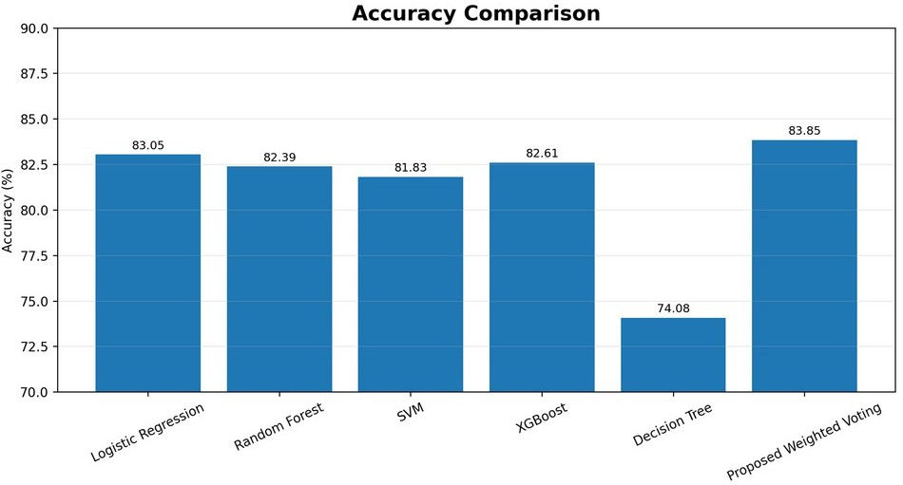

Precision Comparison

Model | Precision
Logistic Regression | 84.16%
Random Forest | 82.62%
SVM | 81.02%
XGBoost | 83.36%
Decision Tree | 71.43%
Proposed Weighted Soft Voting | 84.58%
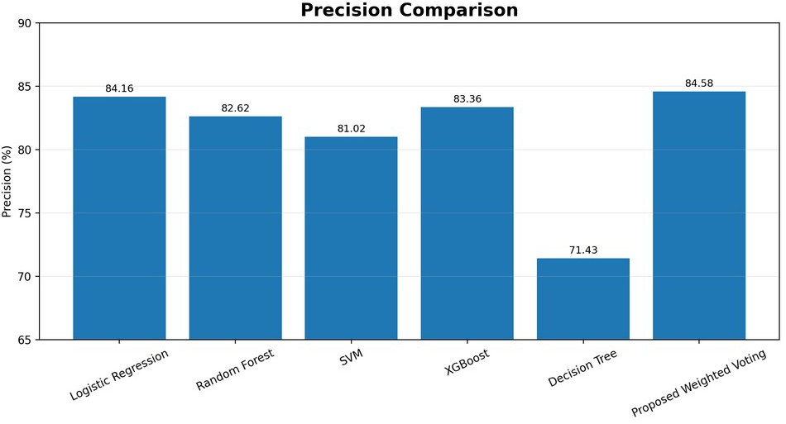

Recall Comparison

Model | Recall
SVM | 79.57%
XGBoost | 78.11%
Decision Tree | 73.78%
Proposed Weighted Soft Voting | 79.81%

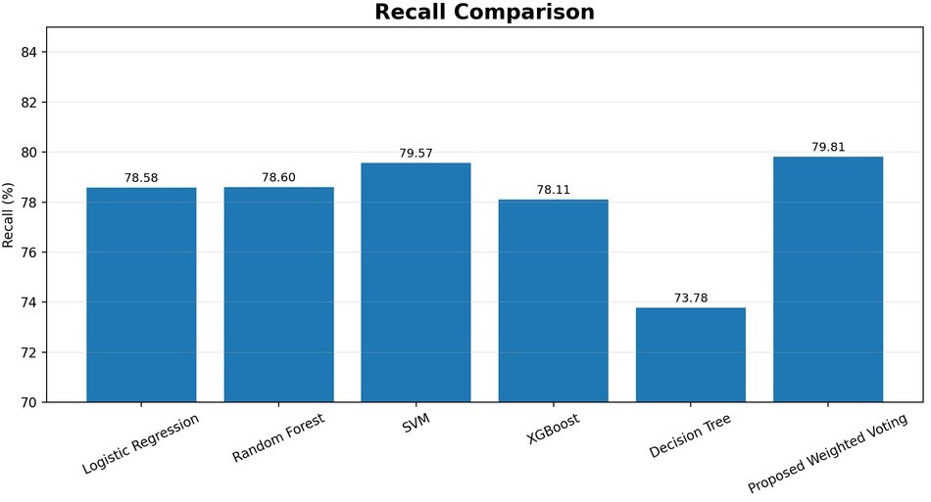

F1-Score Comparison

Model | F1-Score
Logistic Regression | 81.11%
Random Forest | 80.42%
SVM | 80.17%
XGBoost | 80.51%
Decision Tree | 72.39%
Proposed Weighted Soft Voting | 81.97%

ROC-AUC Comparison

Model | ROC-AUC
Logistic Regression | 0.903
Random Forest | 0.904
SVM | 0.897
XGBoost | 0.900
Decision Tree | 0.741
Proposed Weighted Soft Voting | 0.906

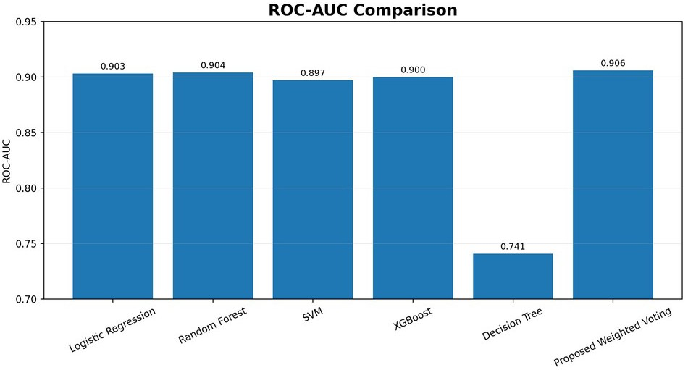

5.2.6. Improvement of Proposed Model

Metric | Best Baseline | Proposed Model | Improvement
Accuracy | 83.05% | 83.85% | +0.80 pp
Precision | 84.16% | 84.58% | +0.42 pp
Recall | 79.57% | 79.81% | +0.24 pp
F1-Score | 81.11% | 81.97% | +0.86 pp
ROC-AUC | 0.904 | 0.906 | +0.002

Model | Recall
Logistic Regression | 78.58%
Random Forest | 78.60%

Study | Dataset / Size | Clinical Features Used | Feature Selection / Engineering | Class Balancing
et al. (2025) | 303 records | Fbs, Restecg, Thalach, Exang, Oldpeak, Slope, CA, Thal | analysis + preprocessing | weighting
Our Proposed Framework | Cleveland dataset, 297 records | Age, Sex, CP, Trestbps, Chol, Fbs, Restecg, Thalach, Exang, Oldpeak, Slope, CA, Thal | Feature Selection | Class balancing

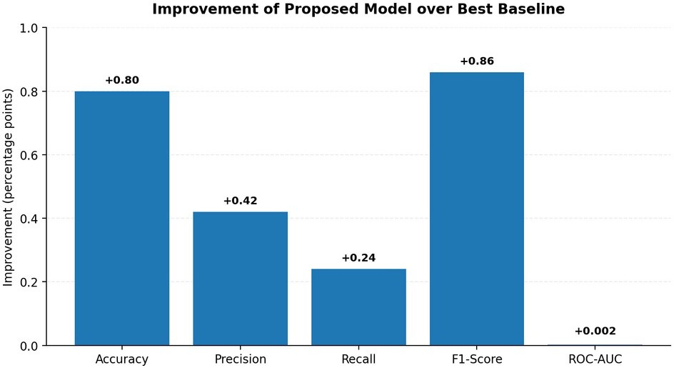
5.2.7 Performance Comparison with Previous Model Combinations

Model / Combination | Accuracy | Precision | Recall | F1 | ROC-AUC
Prior Study 1: SVM + RF + XGBoost + KNN | 83.84% | 84.78% | 79.57% | 81.93% | 0.906
Prior Study 2: DT + KNN + RF + XGBoost | 80.37% | 79.97% | 77.14% | 78.35% | 0.893
Prior Study 3: Extra Trees | 81.38% | 80.72% | 78.85% | 79.67% | 0.898
Prior Study 6: RF + DT + SVM Soft Voting | 78.24% | 77.52% | 74.97% | 76.04% | 0.883
★ OUR PROPOSED MODEL | 83.85% | 84.58% | 79.81% | 81.97% | 0.906
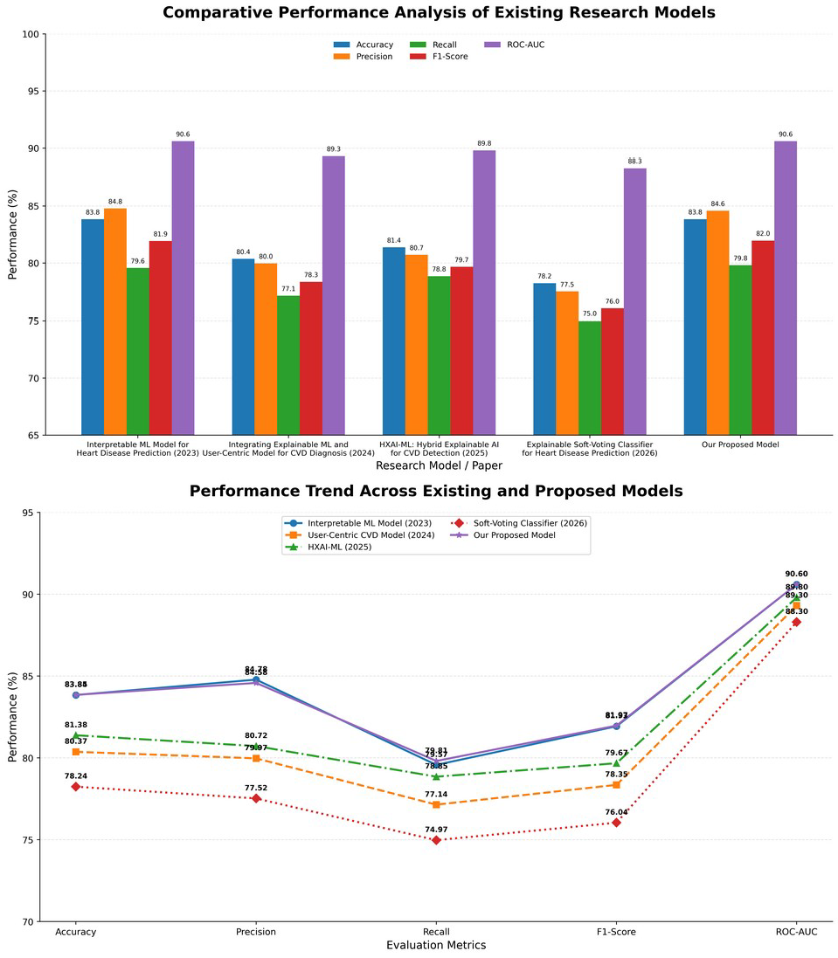

A. Tabular and Graphical Feature Analysis
TABLE I. DATASET & CLINICAL FEATURE COMPARISON
Study | Dataset / Size | Clinical Features Used | Feature Selection / Engineering | Class Balancing
RP-1: Asih et al. (2023) | Cleveland Heart Disease | Age, Sex, CP, Trestbps, Chol, Fbs, Restecg, Thalach, Exang, Oldpeak, Slope, CA, Thal | StandardScaler | Not reported as a main technique
RP-2:  Chakraborty et al. (2026) | Real-world Bangladesh dataset, 5000 patients | Age, Gender, Cholesterol, BP, Heart Rate, Smoking, Alcohol, Exercise, Family History, Diabetes, Obesity, Stress, Blood Sugar, Exercise Angina, Chest Pain | Clinical + laboratory feature integration; RF feature importance | SMOTE
RP-3:  Cenitta et al. (2026) | UCI  Cleveland, 303 records | Age, Sex, CP, Trestbps, Chol, Fbs, Restecg, Thalach, Exang, Oldpeak, Slope, CA, Thal | ISSO feature selection; compared with Chi-Square, ReliefF, RFE and GA | SMOTE
RP-4: Wajid et al. (2025) | Clinical CVD dataset | Age, diabetes, smoking history, exercise, general health and other survey/clinical variables | PCA | ProWRAS
RP-5: Napa | Cleveland, | Age, Sex, CP, Trestbps, Chol, | Correlation | Class

RP-1 explicitly lists the 13 clinical predictors and target in its Cleveland dataset description. RP-1 RP-3 similarly describes the
303-record UCI dataset and its clinical attributes. RP-3 RP-5 uses the same 14-attribute Cleveland structure. RP-5
TABLE II. FEATURE IMPORTANCE / CLINICAL FACTORS COMPARED

Clinical Feature | RP-1 | RP-2 | RP-3 | RP-4 | RP-5 | Our Framework
Age | ✓ | ✓ | ✓ | ✓ | ✓ | ✓
Sex / Gender | ✓ | ✓ | ✓ | — | ✓ | ✓
Chest Pain (CP) | ✓ | ✓ | ✓ | — | ✓ | ✓
Blood Pressure | ✓ | ✓ | ✓ | — | ✓ | ✓
Cholesterol | ✓ | ✓ | ✓ | — | ✓ | ✓
Fasting Blood Sugar | ✓ | — | ✓ | — | ✓ | ✓
Resting ECG | ✓ | — | ✓ | — | ✓ | ✓
Maximum Heart Rate | ✓ | ✓ | ✓ | — | ✓ | ✓
Exercise Angina | ✓ | ✓ | ✓ | — | ✓ | ✓
Oldpeak | ✓ | — | High importance | — | High importance | ✓
Slope | ✓ | — | ✓ | — | ✓ | ✓
Major Vessels (CA) | ✓ | — | High importance | — | High importance | ✓
Thal | ✓ | — | High importance | — | High importance | ✓
Diabetes | — | ✓ | — | High importance | — | —*
Smoking | — | ✓ | — | High importance | — | —*
Exercise | — | ✓ | — | Important | — | —*
Family History | — | ✓ | — | — | — | —*
Stress Level | — | ✓ | — | — | — | —*
RP-3 specifically identifies CA, Thal and Oldpeak as the strongest features in its SHAP analysis. RP-3 RP-5's PDP analysis similarly discusses CA, CP, Thal, Oldpeak and Thalach as clinically meaningful predictors. RP-5

TABLE III. METHODOLOGY COMPARISON

Parameter | RP-1 | RP-2 | RP-3 | RP-4 | RP-5 | Our Framework
Data preprocessing | Standardization | Cleaning + encoding + SMOTE | Imputation + normalization + encoding + outlier handling | Balancing  + PCA | KNN imputation  + encoding + scaling | Cleaning + encoding + scaling + balancing
Feature selection | — | RF-based analysis | ISSO | PCA | Correlation analysis | Feature Selection
Main ML models | SVM, RF,  XGBoost, KNN | LR, DT, SVM, RF | RF | CNN, TCN, DBN | RF, DT, ANN,  KNN, XGBoost, SVM | LR, RF, SVM,  XGBoost
Ensemble | No | Model comparison | RF + selected features | Hybrid / Blending | No | Weighted Soft Voting
SHAP | ✓ | ✓ | ✓ | ✓ | ✓ | ✓
LIME | ✓ | — | ✓ | ✓ | Considered/used | ✓
PDP / ALE | — | ALE | — | — | PDP | Can be included
Feature importance | ✓ | ✓ | SHAP | SHAP | RF + SHAP/PDP | SHAP
Web / Dashboard | Not central | Web application | — | — | GUI | Decision-Support Dashboard

TABLE IV. FEATURE SELECTION COMPARISON

Feature Selection Method | Features Retained | Accura cy | F1 | Main Observation
Chi-Square | 10 | 91.8% | 0.9  1 | Fast but does not account well for feature interdependence
ReliefF | 9 | 92.5% | 0.9  2 | Sensitive to imbalance
RFE | 8 | 93.2% | 0.9  3 | Requires repeated model evaluation
Genetic Algorithm | 7 | 94.0% | 0.9  4 | Good accuracy but slower convergence
ISSO | 6 | 96.4% | 0.9  6 | Highest accuracy with fewer features
Our Feature Selection | To be reported from our implementation | — | — | Used before the weighted ensemble
These exact comparison values come from RP-3's feature-selection comparison table. RP-3
TABLE V. EXPLAINABILITY COMPARISON

Study | Explainability Method | Global Explanation | Patient-Specific Explanation | Main Features Highlighted
RP-1 | SHAP + LIME | SHAP | LIME | Significant clinical variables
RP-2 | SHAP + ALE | SHAP | SHAP | Cholesterol, Age, BP, etc.
RP-3 | SHAP + LIME | SHAP | LIME | CA, Thal, Oldpeak
RP-4 | SHAP + LIME | SHAP | LIME | Diabetes, Age, Smoking, Exercise
RP-5 | SHAP + PDP | SHAP/PDP | SHAP | CA, CP, Thal, Oldpeak, Thalach
Our Framework | SHAP + LIME | SHAP | LIME | Features selected by our model

RP-3 explicitly explains SHAP as the global feature-importance analysis and LIME as the individual-patient explanation. RP-3
Clinical Feature Usage Across Reviewed Studies
Number of reviewed papers that explicitly use each clinical feature.

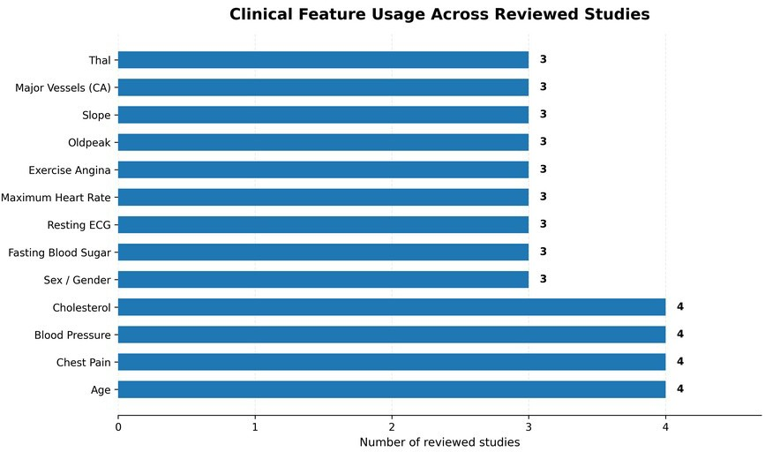
Fig. 1. Clinical Feature Usage Across Previous Studies. Number of Clinical Features Used by Reviewed Studies Comparison of the number of predictors or clinical input features
reported in the reviewed papers.
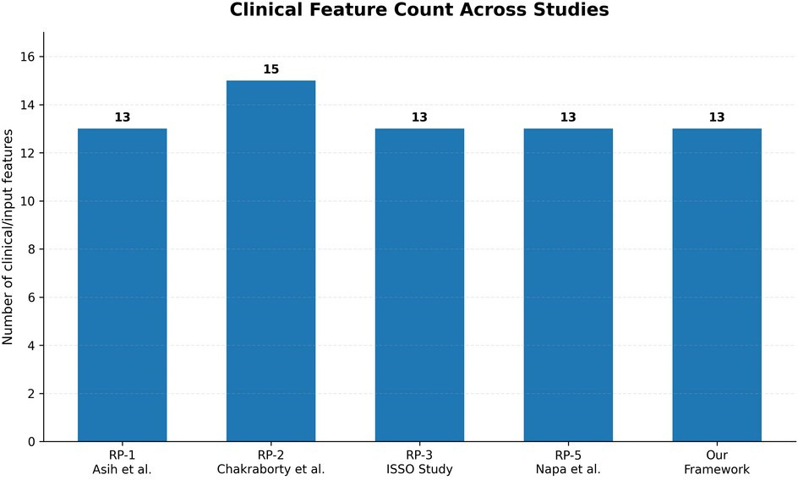
Fig. 2. Number of Clinical Features Used.
This one comes directly from RP-3 and is very useful because it compares both feature reduction and predictive performance.
Feature Selection: Number of Features Retained
Comparison of feature-selection techniques reported in RP-3.
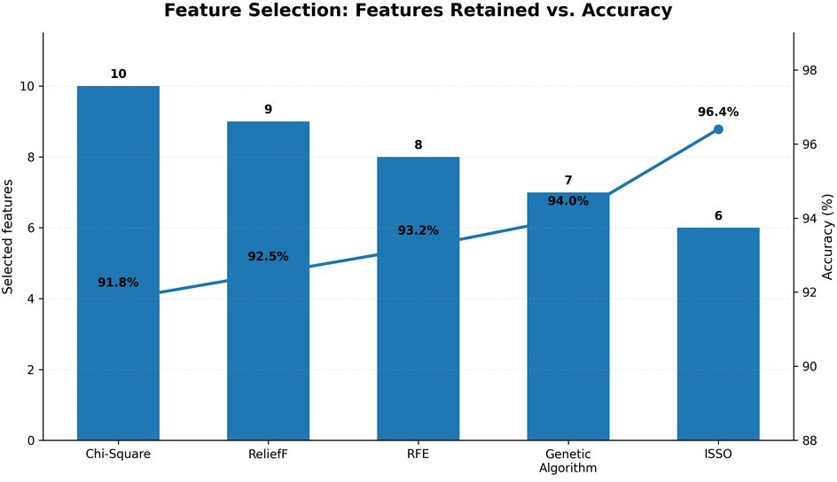
Fig. 3. Feature Selection Comparison.

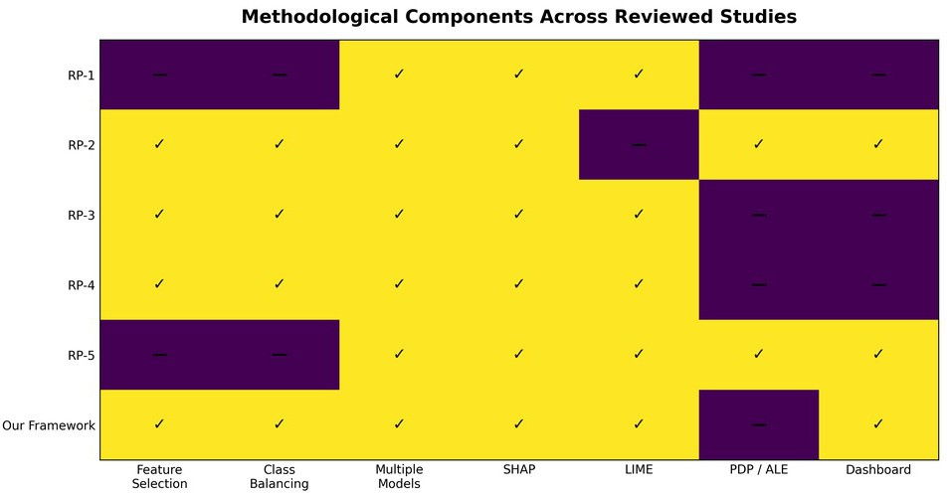
Fig. 4. Methodological Components.
Explainability Techniques Across Reviewed Studies
Number of reviewed papers using each explainability or interpretation technique.
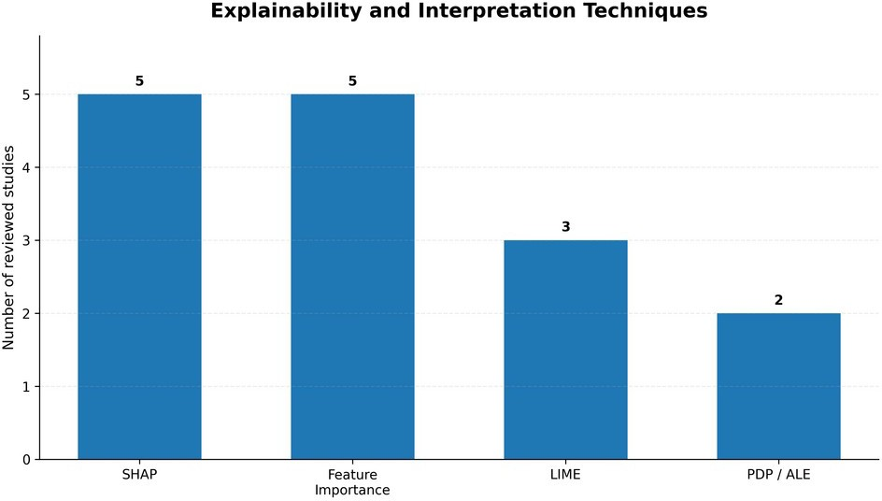
Fig. 5. Explainability Techniques Used.
Our Framework vs Individual Machine Learning Models Cross-validation performance from the proposed heart disease
prediction framework.

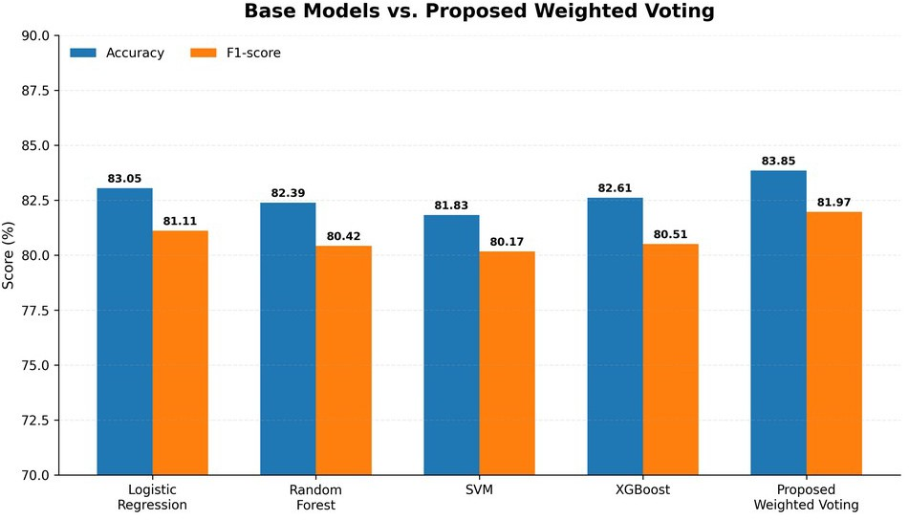
Fig. 6. Our Model vs Base Models.

Confusion Matrix

The confusion matrix needs to provide TP (true positive), TN (true negative), FP (false positive), and FN (false negative) measures. This information is necessary in order to understand how the classifier of heart disease works in practice, especially since FN is a measure that indicates patients whose high risk was not recognized. Real values of confusion matrix are not included in the provided slides and need to be added after the last test run.

TP = [INSERT] TN = [INSERT] FP = [INSERT] FN = [INSERT]

ROC/PR Analysis

ROC-AUC will also be a part of the evaluation process for the project. The presentation of the final project should have the ROC graph showing the comparison between the ensemble model and the individual base models. If there is class imbalance in the data set, a Precision-Recall graph must also be shown because PR analysis focuses on positive predictive accuracy and recall [12]. The given presentation lacks these graphs.

Feature Importance

Importance of the features should be presented based on the final SHAP analysis. As is shown in the project presentation, the SHAP model would give insights into how the features are contributing to the prediction; however, no information about the final ranking of the clinical features is provided in the project presentation. Thus, the importance is assigned to none of the features based on the current draft since there is no evidence in the final run of the SHAP model.

Explainability Results

The desired output is a prediction result along with the reasoning specific to that particular patient. The SHAP approach should deliver the feature importance scores for that particular prediction, whereas the LIME approach should deliver the local surrogate model for that particular patient’s case. An example of that would be provided in the final research paper; however, the current project

specification mentions this output but not the actual example values and screenshot.

Ablation Study

Conducting an ablation experiment will allow you to understand whether each element in the design helps achieve the mentioned performance gain. The following experiments could be done: (A) best single baseline, (B) soft voting without weights, (C) soft voting with weights, (D) voting with weights but without feature selection, and (E) voting with weights and feature selection. These experiments have not been conducted in the current project presentation.

Configuration | Accuracy | F1 | ROC-AUC
Best single baseline | 83.05% | 81.11% | 0.903
Unweighted voting | To be calculated | To be calculated | To be calculated
Weighted voting | To be calculated | To be calculated | To be calculated
Weighted voting + feature selection | 83.85% | 81.97% | 0.906

Statistical Results

Statistical significance is not mentioned in the project material provided. In case statistical tests are not run, no conclusions about statistical significance of the observed changes can be made in the final paper.

DISCUSSION

Interpretation of Findings

Given the gains mentioned above, it can be argued that the designed weighted ensemble delivered better results compared to the best performing baseline in the current project experiment in terms of evaluation metrics. The greatest relative gain is achieved in the F1-score (+0.86 points), while the next gain is in accuracy (+0.80%). Recall was also improved (+0.24 points), which is quite important since the task at hand is rather screening related and identifying positive instances is one of its criteria. Nevertheless, it is important to evaluate the gain taking into account confidence intervals, dataset size, class distribution, and validation process once available.

The rationale behind the designed ensemble is complementarity: Logistic Regression gives linear probability view; Random Forest uses trees to find complex interactions; SVM gives a margin based view; and XGBoost offers boosted trees modeling. Ensemble techniques allow combining several classifiers and potentially improving their performance provided that they make different mistakes [8].

Comparison With Previous Studies

Past works indicate that performance in predicting heart disease depends on the specific population and dataset used. Works carried out using hospital data from south India assessed various traditional machine learning models used in the early detection of cardiovascular diseases [26]. Some other works have proposed ensemble approaches towards cardiovascular diseases and shown comparable performance [27,30]. One work published in 2025 even combined ensemble techniques with XAI in heart disease prediction on various datasets [24,25].

In the present work, there is a difference in the architecture used, in which feature selection is done first, then a four-model weighted soft voting ensemble follows, in which Decision Tree serves only as a baseline approach, while SHAP and LIME follow in predicting the outcome.

Theoretical Implications

The proposed framework shows how heterogeneous ensemble learning and post-hoc explanation can be combined into a well-defined process pipeline. The prediction task is distinguished from the explanation one: the former is performed by the ensemble, whereas SHAP and LIME offer explanations. The distinction reflects common practices in XAI research where post-hoc explanation methods are applied to interpret complicated prediction algorithms [18 23].

Practical Implications

A decision-making system would definitely get better results if not only the risk category was provided but also the reasons behind the model’s output. In such a way, the system suggested in the project will use the data regarding the health parameters of the patient, process them using the machine learning pipeline and show the result together with explanations for the prediction provided by the ensemble of SHAP and LIME methods. However, the system should be seen as a decision support tool rather than a diagnostic one.

Unexpected Findings

The unexpected results do not occur in the project presentation. The current findings indicate positive differences in all five metrics when compared with the best baseline. In order to write a good paper, it is necessary to include unexpected results if there will be any during the experiment, such as model inconsistency, contradiction in explanations, etc.

LIMITATIONS

• The dataset version, sample size, class distribution, and selected features of the dataset provided with the project are unknown.

• Tangible metrics of performance are not included in the

presentation. Instead, the report provides relative improvements over the best baseline.

• Information regarding the final train/test split, cross-validation strategy used in the experiment, random seed value, and configuration of the hyperparameters is not available.

• The specific feature selection method and the resulting feature set are not mentioned.

• The specific weights of the ensemble and the classification threshold are not known.

• Any statistical tests or confidence intervals are not provided.

• External validation of the classifier is not carried out using an additional dataset.

• SHAP and LIME can provide explanations of how the

model works but cannot prove causality between the clinical parameters and the disease.

• The current system can be considered a research prototype only.

CONCLUSION AND FUTURE WORK

The above-presented paper outlined an Explainable Ensemble Machine Learning Framework for Early Heart Disease Prediction based on the architecture described in the project review. The framework involves data preprocessing, feature selection, four classifiers, weighted soft voting, and post-hoc explanations with the use of SHAP and LIME. The Decision Tree classifier is retained as the baseline and does not form part of the ensemble. In terms of the project results obtained so far, the proposed ensemble outperforms the best baseline in terms of accuracy, precision, recall, F1-score, and ROC-AUC by 0.80 percentage points, 0.42 points, 0.24 points, 0.86 points, and 0.24 points, respectively. Thus, the system shows the expected performance and interpretation capabilities, while the rest of experimental results need to be provided upon final execution of the model.
Future work may involve the evaluation on bigger and more varied datasets, external validation of results among other populations, the calibration of predictions, enhanced cross-validation, estimation of confidence intervals and statistical significance, ablation studies, explanation-stability analysis, better visualization with the use of dashboards, and study of different ensembles and XAI methods. Clinical validation will have to be performed prior to the practical application of the system.

DECLARATIONS

Funding
No external funding information is provided in the supplied project material.

Conflict of Interest
The authors should confirm and insert the appropriate conflict-of-interest statement before submission.

Ethics Statement

The research is using a publicly available machine learning dataset as per the project description. The final draft must mention the specific dataset and verify its relevant data and ethical requirements.

Data Availability
The exact dataset source used in the final implementation should be stated here, together with the public repository link.

Author Contributions
Katta Anoop, V. Sree, Sameera M, and Souraja M contributed to the project development and research-paper preparation under the guidance of Dr. K. Swanthana. The authors should revise this statement to reflect their exact individual contributions before submission.

ACKNOWLEDGEMENTS
The authors acknowledge Dr. K. Swanthana for guidance and support during the development of the project.

REFERENCES
- World Health Organization, “Cardiovascular diseases (CVDs),” WHO Fact Sheet, 31 July 2025.
- R. Detrano, A. Janosi, W. Steinbrunn, M. Pfisterer, J. J. Schmid,
S. Sandhu, K. H. Guppy, S. Lee, and V. Froelicher, “International application of a new probability algorithm for the diagnosis of coronary artery disease,” The American Journal of Cardiology, vol. 64, no. 5, pp. 304–310, 1989. doi:10.1016/0002-
9149(89)90524-9.
- A. Janosi et al., “Heart Disease,” UCI Machine Learning Repository, dataset 45.
- D. W. Hosmer and S. Lemeshow, Applied Logistic Regression, 2nd ed., Wiley, 2000.
- C. Cortes and V. Vapnik, “Support-vector networks,” Machine Learning, vol. 20, pp. 273–297, 1995. doi:10.1007/BF00994018.
- L. Breiman, “Random forests,” Machine Learning, vol. 45, pp. 5–32, 2001. doi:10.1023/A:1010933404324.
- T. Chen and C. Guestrin, “XGBoost: A scalable tree boosting system,” in Proc. 22nd ACM SIGKDD Int. Conf. Knowledge Discovery and Data Mining, pp. 785–794, 2016. doi:10.1145/2939672.2939785.
- T. G. Dietterich, “Ensemble methods in machine learning,” in Multiple Classifier Systems, LNCS 1857, pp. 1–15, Springer, 2000. doi:10.1007/3-540-45014-9_1.
- N. V. Chawla, K. W. Bowyer, L. O. Hall, and W. P. Kegelmeyer, “SMOTE: Synthetic minority over-sampling technique,” Journal of Artificial Intelligence Research, vol. 16, pp. 321–357, 2002. doi:10.1613/jair.953.
- I. Guyon and A. Elisseeff, “An introduction to variable and feature selection,” Journal of Machine Learning Research, vol. 3,
pp. 1157–1182, 2003.
- T. Fawcett, “An introduction to ROC analysis,” Pattern Recognition Letters, vol. 27, no. 8, pp. 861–874, 2006. doi:10.1016/j.patrec.2005.10.010.
- T. Saito and M. Rehmsmeier, “The precision-recall plot is more informative than the ROC plot when evaluating binary classifiers on imbalanced datasets,” PLOS ONE, vol. 10, no. 3, e0118432, 2015. doi:10.1371/journal.pone.0118432.
- F. Pedregosa et al., “Scikit-learn: Machine learning in Python,” Journal of Machine Learning Research, vol. 12, pp. 2825–2830, 2011.
- C. R. Harris et al., “Array programming with NumPy,” Nature, vol. 585, pp. 357–362, 2020. doi:10.1038/s41586-020-2649-2.
- J. D. Hunter, “Matplotlib: A 2D graphics environment,” Computing in Science & Engineering, vol. 9, no. 3, pp. 90–95, 2007. doi:10.1109/MCSE.2007.55.
- W. McKinney, Python for Data Analysis, 2nd ed., O’Reilly Media, 2017.
- T. Kluyver et al., “Jupyter Notebooks—A publishing format for reproducible computational workflows,” in Positioning and Power in Academic Publishing: Players, Agents and Agendas, IOS Press,
pp. 87–90, 2016.
- M. T. Ribeiro, S. Singh, and C. Guestrin, “‘Why should I trust you?’: Explaining the predictions of any classifier,” in Proc. 22nd ACM SIGKDD Int. Conf. Knowledge Discovery and Data Mining, pp. 1135–1144, 2016. doi:10.1145/2939672.2939778.
- S. M. Lundberg and S.-I. Lee, “A unified approach to interpreting model predictions,” in Advances in Neural Information Processing Systems 30, pp. 4765–4774, 2017.
- S. M. Lundberg et al., “From local explanations to global understanding with explainable AI for trees,” Nature Machine Intelligence, vol. 2, pp. 56–67, 2020. doi:10.1038/s42256-019-
0138-9.
- S. N. Payrovnaziri et al., “Explainable artificial intelligence models using real-world electronic health record data: A systematic scoping review,” Journal of the American Medical Informatics Association, vol. 27, no. 7, pp. 1173–1185, 2020. doi:10.1093/jamia/ocaa053.
- “How Explainable Artificial Intelligence Can Increase or Decrease Clinicians’ Trust in AI Applications in Health Care: Systematic Review,” systematic review indexed in PubMed/PMC, 2024.
- “Essential properties and explanation effectiveness of explainable artificial intelligence in healthcare: A systematic review,” systematic review, 2023.
- A. A. Adekoya, F. Saeed, W. Ghaban, and S. N. Qasem, “Ensemble learning approach with explainable AI for improved heart disease prediction,” Frontiers in Pharmacology, 2025.
- S. M. Ganie, P. K. Dutta Pramanik, and Z. Zhao, “Ensemble learning with explainable AI for improved heart disease prediction based on multiple datasets,” Scientific Reports, vol. 15, article 13912, 2025.
- “Machine learning-based heart disease prediction system for Indian population: An exploratory study done in South India,” Medical Journal, Armed Forces India, 2021. doi:10.1016/j.mjafi.2020.10.013.
- “Ensemble framework for cardiovascular disease prediction,” Computers in Biology and Medicine, 2022.
- “Using machine learning algorithms to identify chronic heart disease: National Health and Nutrition Examination Survey 2011–2018,” 2023.
- “Logistic regression was as good as machine learning for predicting major chronic diseases,” Journal of Clinical Epidemiology, 2020. doi:10.1016/j.jclinepi.2020.03.002.
- “Ensemble of heterogeneous classifiers for diagnosis and prediction of coronary artery disease with reduced feature subset,” Computers in Biology and Medicine, 2020. doi:10.1016/j.cmpb.2020.105770.

- “Comparative analysis of heart disease prediction using logistic regression, SVM, KNN, and random forest with cross-validation for improved accuracy,” 2025.
- “Interpretability of Clinical Decision Support Systems Based on Artificial Intelligence from Technological and Medical Perspective: A Systematic Review,” 2023.

FINAL DATA TO INSERT BEFORE SUBMISSION
The provided PPT is enough to demonstrate the architecture and relative improvements made, but the below-listed items are not present and need to be copied from the final notebook/code before considering the paper as experimentally completed:
• Name of the dataset, source/repo, version, number of records, features, and classes.
• Training/test/validation split and random seed used.
• Type of data preprocessing and class balancing technique.
• Technique used for feature selection and selected features.
• Hyperparameters for all five baseline models.
• Weights of the four ensemble models and decision threshold.
• Accuracy, Precision, Recall, F1-Score, and ROC-AUC values of each model.
• Values of confusion matrix.
• ROC and PR plots.
• Plot of SHAP ranking of features and top values.
• LIME example for patients.
• Cross-validation results.
• Statistical significance results (if any).
• Screenshot of prediction dashboard.

